**Chi****SNACK SQUAD: A CUSTAMISABLE SNACK**

**ORDERING AND DELIVERY APP**

College code : 8120

College Name : M.A.M.COLLEGE OF ENGINEERING

AND TECHNOLOGY

Total number of students:3

SUBMITTED BY:

Preethija . G -812022104055

Priyadharshini . M – 812022104057

Suveetha . A - 812022104083

**CONTENT :**

* Abstract
* Introduction
* Motivation
* Problem statement
* Objectives and Goals
* Project Perspective
* Performance Requirements
* Security Requirements
* Python program for Snack Squad
* Conclusion and Recommendations

**ABSTRACT::**

Online Food Ordering System is proposed for simplifies the food ordering process. This

System shows an user interface and update the menu with all available options so that it eases the

customer work. Customer can choose more than one item to make an order and can view Order

details before logging off. The order confirmation is sent to the customer. The order is placed in

the queue and updated in the Database and returned in real time. This system assists the staff to

go through the orders in real time and process it efficiently. Online food order system is mainly

designed primarily function for use in the food delivery industry. This system will allow

hotels and restaurants to increase online food ordering such type of business. The customers

can be selected food menu items just few minutes. In the modern food industries allows to

quickly and easily delivery on customer place. Restaurant employees then use these orders

through an easy to delivery on customer place easy find out navigate graphical interface for

efficient processing.

**INTRODUCTION:**

The Online Ordering System can be defined as a simple and convenient way for customers to

purchase food online, without having to go to the restaurant.

This system is enabled by the internet – it is the internet that connects the restaurant or the food

company on one hand, and the customer on other hand.

Therefore, as per this system, the customer visits the restaurant’s website, browses through the

various food items available there and goes ahead and selects and purchases the items he or she

needs.

These items will then be delivered to the customer at his or her doorstep at the time they choose

by a delivery person.

Payments for such online orders can be made through debit cards, credit cards, cash or card on

delivery, or even through digital wallets.

This system for online food delivery is completely safe, secure and is a very popular method that

is revolutionizing the way in which the food industry operate.

Here we Propose an “Online Food Ordering System” that has been Designed for Fast Food

restaurant, Take-Out or College Cafeterias. The system can also be used in any food delivery

industry. This simplifies the process of food ordering for both the customer and the restaurant, as

the entire process of taking orders is automated.

The main advantage of my system is that it greatly simplifies the ordering process for both the

customer and the restaurant. When the customer visits the ordering webpage, they are presented

with an interactive and up-to-date menu,complete with all available options and dynamically

adjusting prices based on the selected options. After making a selection, the item is then added to

their order, which the customer can review the details of at any time before checking out.

**MOTIVATION:**

1. It reduce manual work.

2. The online food delivery system is overcome the problems in manual system.

3. This system is fully computerized.

4. It is user friendly.

5. Provide quickly reports.

6. Highly efficient and accurate.

7. Prevention of unauthorised access of data.

8. Automated.

**PROBLEM STATEMENT:**

1. Some of the major problems reported by the customers surveyed revolved around late

deliveries because of network problem

2. incorrect orders being delivered due to communication problem.

3. orders not being delivered at all, rude customer service.

4. , cold food being delivered, and the driver requiring a lot of guidance to find the delivery

location.

5. Sometime payment issue is occurred.

6. Online food ordering system service now days increase your budget.

7. lack of a visual confirmation that the order was placed correctly.

**OBJECTIVES AND GOALS:**

The proposed system is developed to manage ordering activities in fast food restaurant. It helps

to record customer submitted orders. The system should cover the following functions in order to

support the restaurant’s business process for achieving the objectives:

1. To allow the customer to make order, view order and make changes before submitting their

order and allow them make payment through prepayment card or credit card or debit card.

2. To provide interface that allows promotion and menu.

3. To prevent interface that shows customers’ orders detail to front-end and kitchen staffs for

delivering customers’ orders

4. Tools that generate reports that can be used for decision making

5. A tool that allows the management to modify the food information such as price, add a new

menu and many others as well as tools for managing user, system menu and promotion records.

This will minimize the number of employees at the back of the counter.

The main objective of the Online Food Ordering System is to manage the details of Item

Category , Food , Delivery Address, Order ,Shopping Cart. ... The purpose of the project is to build

an application program to reduce the manual work for managing the Item Category, Food,

Customer, Delivery Address.

**PROJECT PERSPECTIVE:**

The Online Food Order System application is a web-based system. This web site provide

complete product to place review, order and order processing. It can be accessed through internet

browsers on pc, laptop etc.

System Model:

The structure of the system can be divided into 3 main logical components:

1. Web Ordering System: provides the functionality for customers to place their order and

details.

2. Menu Management: allows the restaurant to manage what can be ordered by the customers.

3. Order Retrieval System: Enables eatery to monitor allorders put. This segment deals with

arrange recovering and showing request data.

Product Function: The Online Food Order System application would have the following basic

functions: 1. Web Ordering System Module This module gives the usefulness to clients to put in

their request and essential points of interest for route. It includes the following module:

1. Home page

2. Meal plan page

3. My cart page

4. Login page

2. Menu Management: Here, the food items and its properties are update/delete for displaying

to user by admin:

1. food item

2. food size

3. food price

4. food image

5. food description

3. Order Retrieval: this is the logical component where all the placed orders are processed by

the restaurent employees

1. Order plan

2. Order quantity

3. Delivery

**PERFORMANCE REQUIREMENTS:**

1. Improve perfect food delivery System.

2. Operations are done within few seconds.

3. User friendly and Mobile-Friendly Website

4. Highly Customizable.

5. Content management system

6. Social media integration

7. Customer Support and Interface

8. Product comparison and user-generated reviews

9. Appropriate operation output will be displayed to within few second.

10. When the selection is made and confirmed by the customer, the receipt shall be produced

within some seconds.

**SECURITY REQUIREMENTS:**

1. Customer Identification

2. Pages of the website must be access in the way they were intended to be accessed.

3. Included files shall not be accessed outside of their parent file

4. Administrator can only perform administrative task on pages they are privileged to

access.

5. Customers will not be allowed to access the administrator pages.

**SOURCE CODE FOR SNACK SQUAD**:

Package com.example.snackordering

Import android.icu.text.SimpleDateFormat

Import android.os.Bundle

Import android.util.Log

Import androidx.activity.ComponentActivity

Import androidx.activity.compose.setContent

Import androidx.compose.foundation.Image

Import androidx.compose.foundation.layout.*

Import androidx.compose.foundation.lazy.LazyColumn

Import androidx.compose.foundation.lazy.LazyRow

Import androidx.compose.foundation.lazy.items

Import androidx.compose.material.MaterialTheme

Import androidx.compose.material.Surface

Import androidx.compose.material.Text

Import androidx.compose.runtime.Composable

Import androidx.compose.ui.Modifier

Import androidx.compose.ui.graphics.Color

Import androidx.compose.ui.layout.ContentScale

Import androidx.compose.ui.res.painterResource

Import androidx.compose.ui.unit.dp

Import androidx.compose.ui.unit.sp

Import com.example.snackordering.ui.theme.SnackOrderingTheme

Import java.util.*

Class AdminActivity : ComponentActivity() {

Private lateinit var orderDatabaseHelper: OrderDatabaseHelper

Override fun onCreate(savedInstanceState: Bundle?) {

Super.onCreate(savedInstanceState)

orderDatabaseHelper = OrderDatabaseHelper(this)

setContent {

SnackOrderingTheme {

// A surface container using the ‘background’ color from the theme

Surface(

Modifier = Modifier.fillMaxSize(),

Color = MaterialTheme.colors.background

) {

Val data=orderDatabaseHelper.getAllOrders();

Log.d(“swathi” ,data.toString())

Val order = orderDatabaseHelper.getAllOrders()

ListListScopeSample(order)

}

}

}

}

}

@Composable

Fun ListListScopeSample(order: List<Order>) {

Image(

painterResource(id = R.drawable.order), contentDescription = “”,

alpha =0.5F,

contentScale = ContentScale.FillHeight)

Text(text = “Order Tracking”, modifier = Modifier.padding(top = 24.dp, start = 106.dp, bottom = 24.dp ), color = Color.White, fontSize = 30.sp)

Spacer(modifier = Modifier.height(30.dp))

LazyRow(

Modifier = Modifier

.fillMaxSize()

.padding(top = 80.dp),

horizontalArrangement = Arrangement.SpaceBetween

){

Item {

LazyColumn {

Items(order) { order ->

Column(modifier = Modifier.padding(top = 16.dp, start = 48.dp, bottom = 20.dp)) {

Text(“Quantity: ${order.quantity}”)

Text(“Address: ${order.address}”)

}

}

}

}

}

}

**OUTPUT:**

Snack Squad App

Enter your name: John Doe

Enter your address: 123 Main St

Menu:

1. Chips - $2.99

2. Popcorn - $3.99

3. Soda - $1.99

4. Candy - $1.49

Enter snack number to add to order (0 to finish): 1

Menu:

1. Chips - $2.99

2. Popcorn - $3.99

3. Soda - $1.99

4. Candy - $1.49

Enter snack number to add to order (0 to finish): 2

Menu:

1. Chips - $2.99

2. Popcorn - $3.99

3. Soda - $1.99

4. Candy - $1.49

Enter snack number to add to order (0 to finish): 0

Your Order:

1. Chips - $2.99

2. Popcorn - $3.99

Total: $6.98

Enter payment method (Cash/Card): Card

Enter card number: 123456789

Card payment successful.

Order confirmed for John Doe at 123 Main St.

This Python program demonstrates basic functionality for Snack Squad:

1. User authentication (name and address)

2. Snack selection and ordering

3. Order summary and total calculation

4. Payment processing (cash or card)

5. Order confirmation

Note that this is a simplified example and may require additional features and validation for a real-world application.

**LOGIN PAGE:**

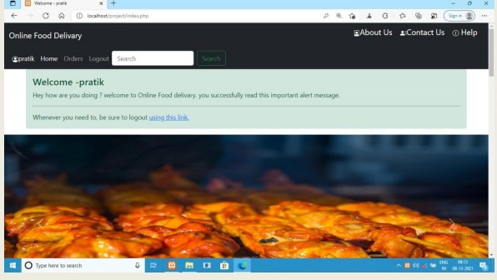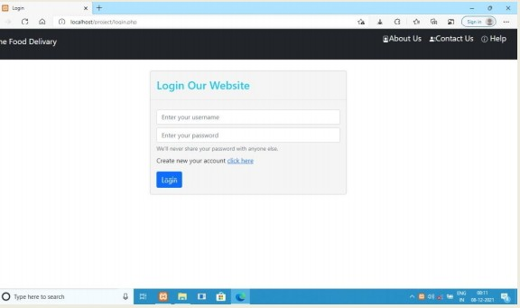

**INDEX PAGE:**

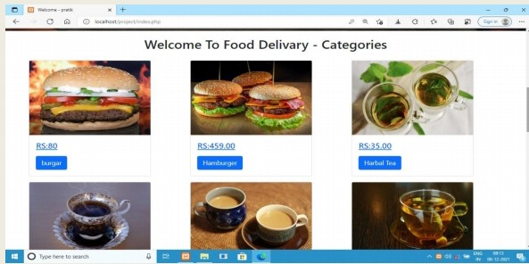

**SEARCH FOOD:**

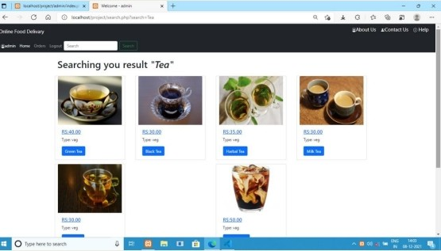

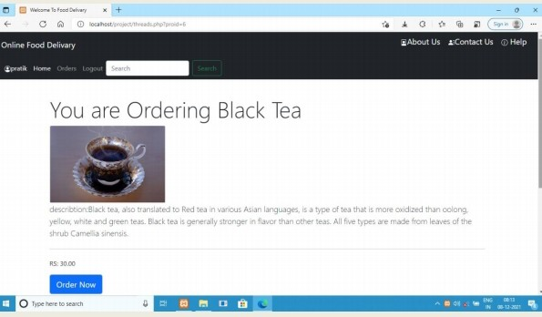**FOOD DETAILS:**

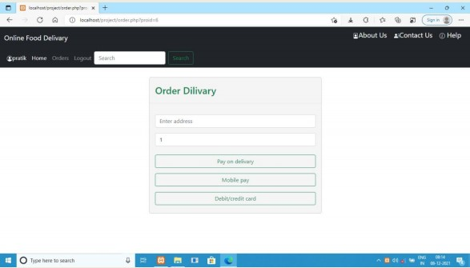

**MOBILE PAYING PAGE:**

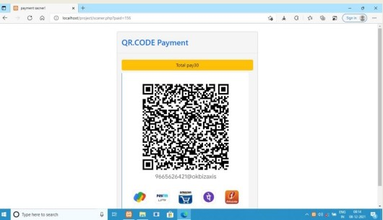

**DEBIT OR CREDIT CARD PAGE :**

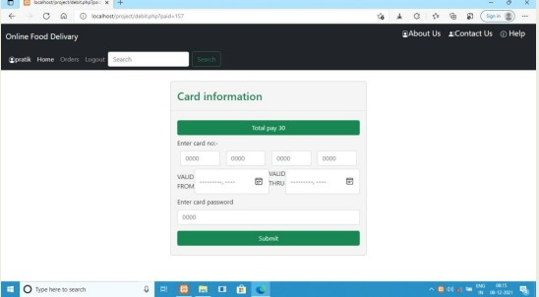

**ORDER SUCCESS:** 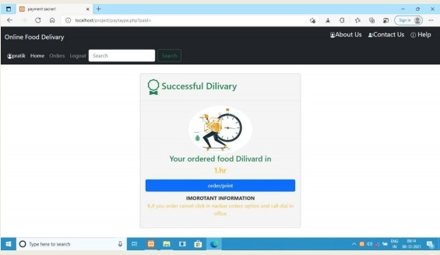

**CONCLUSION AND RECOMMENDATION:**

**CONCLUSION:**

The main objective of the application is to help Computer Science students

understands the basics of Java, JavaScript and HTML. The following results have been achieved

after completing the system and relate back to the system’s objective.

* Should allow Computer Science students to browse through the code and application: This can

be achieved when students are able to run and install the application. When they run the

application, they can browse through the implementation of different objects

Overall we have created application in focus of future food delivary system.

**FUTURE SCOPE:**

The following section describes the work that will be implemented with future releases of the

software.

Customize orders: Allow customers to customize food orders

* Enhance User Interface by adding more user interactive features. Provide Deals and

promotional Offer details to home page. Provide Recipes of the Week/Day to Home Page

* Payment Options: Add different payment options such as PayPal, Cash, Gift Cards etc. Allow

to save payment details for future use.

* Allow to process an order as a Guest

* Delivery Options: Add delivery option

* Order Process Estimate: Provide customer a visual graphical order status bar

* Order Status: Show only Active orders to Restaurant Employees.

* Order Ready notification: Send an Order Ready notification to the customer

* Restaurant Locator: Allow to find and choose a nearby restaurant

* Integrate with In store touch screen devices like iPad.